**Curriculum Vitae**

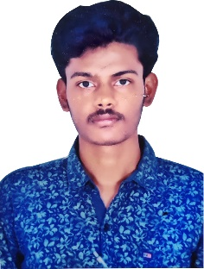

**BHUVANESHWARACHARY KODAKANTI**

**Contact:**

**E-mail** : [20691E00K2@mits.ac.in](mailto:20691E00K2@mits.ac.in)

**Personal E-mail**: buni1244@gmail.com Phone **Number**: 7981386238

_______________________________________________________________________________________

**Objective**

Seeking an entry-level position to begin my career in a high-level professional

Environment in Human Resource Management.

**Education**

* Pursuing as Master of Business Administration in MITS Madanpalli

• Degree in Bachelor of Business Administration (B.B.A) at Sri Srinivasa degree college madanpalli during 2017-2020 with 75% from S.V University

• Intermediate in M.P.C during 2015-2017 with 52% at ADITYA JUNIOR COLLEGE, MADANAPALLI from Andhra Pradesh open School Society, Guntur.

• SSC during 2014-2015 with 62% at MJPA BC WR SCHHOL SRISAILAM DAM EAST, KURNOOL Dist from Board of Secondary Education Andhra Pradesh.

**PERSONAL STRENGTH**

* Quick adaptability to any environment.
* Positive attitude.

**IT EXPOSURE**

* Operating system : Windows XP/NT/2000
* Packages : M.S Office 2007, Python, AWS, HTML, CSS, C, SQL, Excel

**Achievements**

* Participated in entrepreneurship in management meet.
* Participated in group discussions.

**Place: Signature**

**Date: K. Bhuvaneshwar achary**

**PERSONAL INFORMATION**

* FATHER’SNAME : K. RATHNA KUMAR ACHARY
* DATE OF BIRTH : 12/05/1999
* NATIONALITY : INDIAN
* MARITAL STATUS : SINGLE
* LANGUAGES KNOWN : ENGLISH, TELUGU
* Participated in the Guest Lecture on “**Career Guidance for Graduates**” by **Mr.Gowda, Motivational Speaker and Sr.Manager**, Corporate Relations in MITS Madanapalle, organized in our College during June 2019.
* Participated in “**Padmavyuha**”, **internal Management Meet** Conducted by **Department of B.B.A at Sri Srinivasa Degree College, Madanapalli** in the month of August 2018.
* Effectively **organized** and **participated** in many **Seminars, Industrial Visits and Cultural fests** during my 3 years of **B.B.A** Career in **Sri Srinivasa Degree College, Madanapalli.**